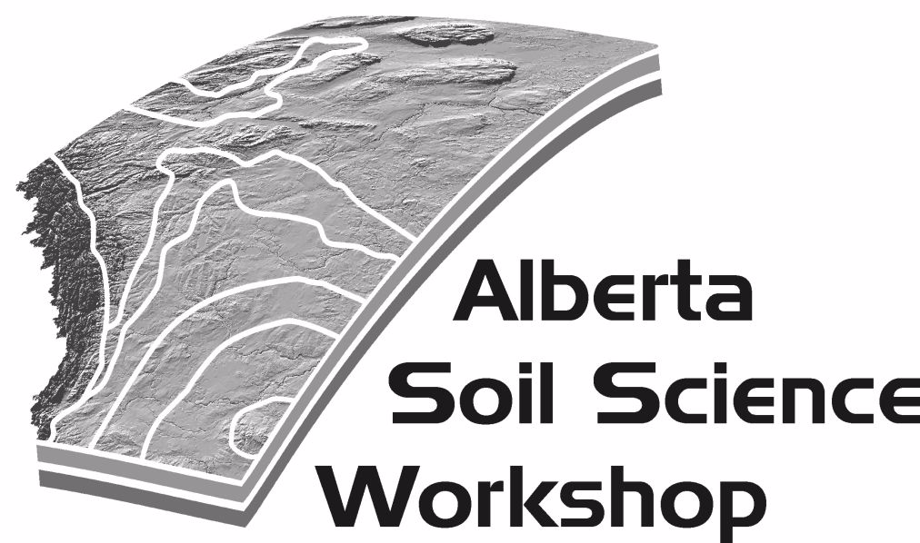
2017 ALBERTA SOIL SCIENCE WORKSHOP
What is Soil Health? Concepts to Applications
February 15-17th 2017

Venue:

Lethbridge, Alberta at the Coast Hotel and Conference Centre. Please contact the Coast Hotel to book your room at 403-327-5701 or book online at www.coasthotels.com.

Registration:

Registration is now open. Please visit www.soilsworkshop.ab.ca for the latest updates.

Travel to Lethbridge: In order to reduce the number of individual travelers on the road, there will be bus transportation available to ALL attendees at a reduced rate ($75 roundtrip from Edmonton).

Sponsorship:
Commercial displays and sponsorships are welcomed. Please contact Derek MacKenzie for more information (mdm7@ualberta.ca).

Call for Papers:
Submission of abstracts deadline has been extended to January 29th, 2017. We are inviting title and abstract submissions for the following technical sessions: technology and soil science, land reclamation; land use and rangelands; soil fertility; forest, wetland and riparian soils; and volunteer. To submit a title, please visit www.soilsworkshop.ab.ca, download and complete a template and email to: soilsworkshop@gmail.com by January 29th, 2017.

Plenary Speakers:
Henry Janzen (Agriculture and Agri-Food Canada)
Chuck Bulmer (University of British Columbia)
Frank Larney (Agriculture and Agri-Food Canada)
Yamily Zavala (Chinook Applied Research Association)

Pre-Workshop Activity:

David Spiess (Alberta Agriculture and Forestry)

The interactive pre-conference workshop is for the environmental and reclamation practitioner and others interested in becoming proficient in the fundamentals of the Alberta Soil Information Viewer.

ASSW Committee:
Past- chair: Amanda Schoonmaker
Chair: Preston Sorenson
Treasurer/Sponsorship: Derek MacKenzie
Secretary: Janna Casson

Technical Sessions:
Preston Sorenson (Technology and Soil Science); Deo A. Heeraman (Land Reclamation); Karen Raven (Land Use and Rangelands); Len Kryzanowski (Soil Fertility); Bin Xu (Forest, Wetland and Riparian Soils); Konstantin Dlusskiy (Volunteer)

